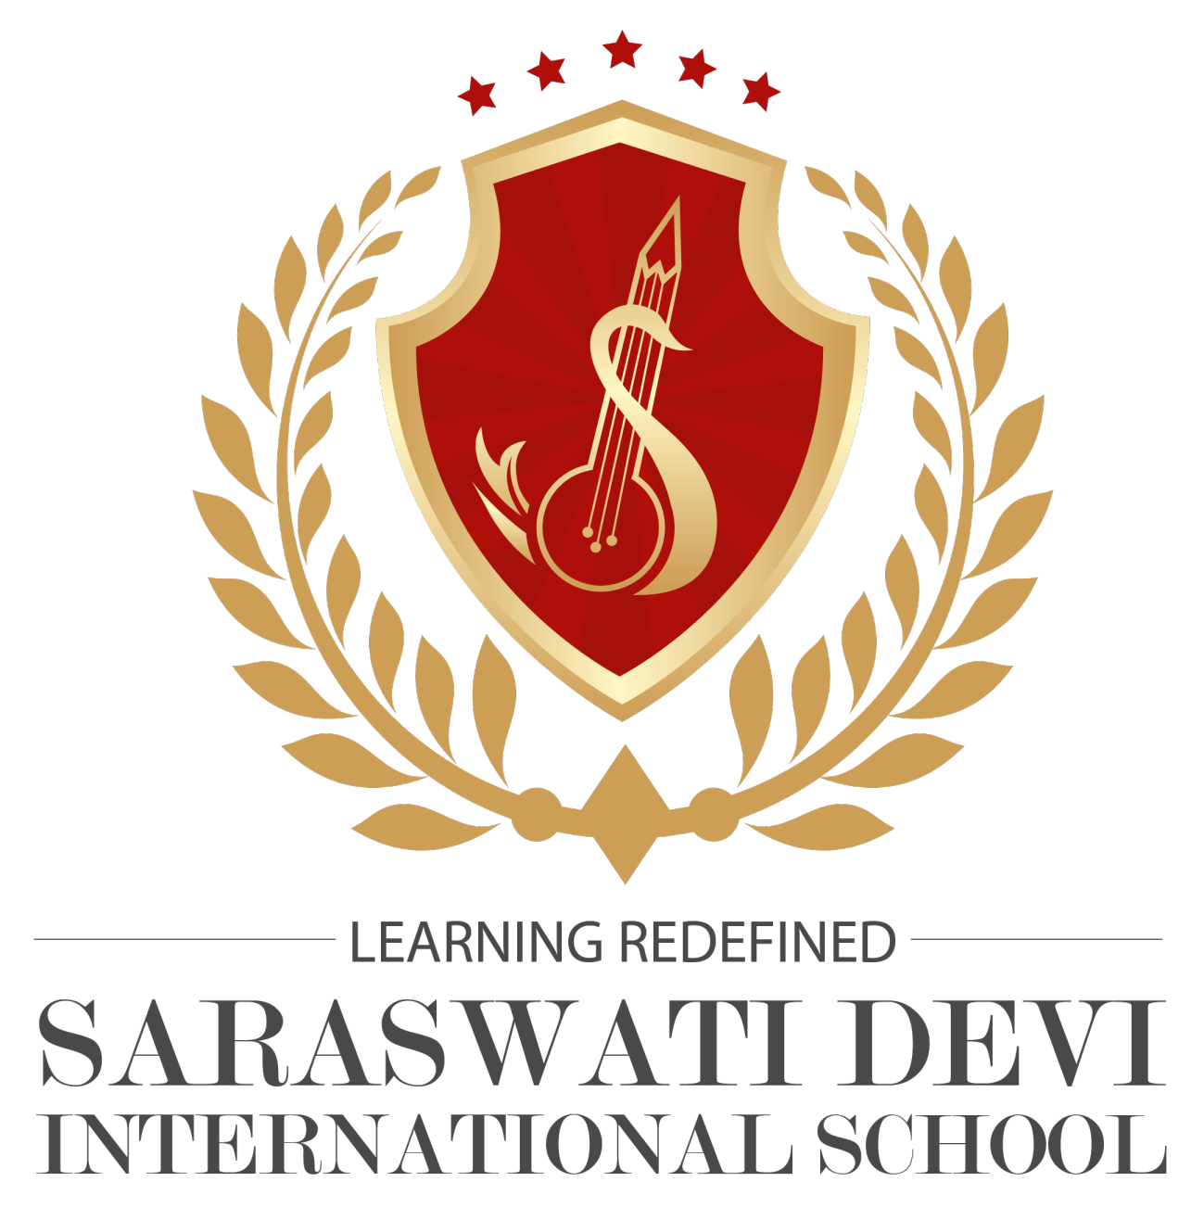
SARASWATI DEVI INTERNATIONAL SCHOOL
Puabagan :: Damodarpur :: Bankura :: PIN-722146 (W.B.)
CLASS - II SEC: A,B |  | SUB: Hindi | DATE:02.05.2021 |  | Teacher's Name: Sayma Khatoon
SL.NO. | NAME |  |  | M.O. |  | FM.
1 | Hiya Patra |  |  | 20 |  | 20
2 | Aishani Shit |  |  | 16 |  | 20
3 | Afia Joynob |  |  | 16 |  | 20
4 | Pratusha Patwari |  |  | 19 |  | 20
5 | Sparsh Drolia |  |  | 20 |  | 20
6 | Sonam Mondal |  |  | 19 |  | 20
7 | Arpan chattait |  |  | 16 |  | 20
8 | Priyank Ganguli |  |  | 20 |  | 20
9 | Shafin Alam |  |  | 17 |  | 20
10 | Ayushman singh Mukherjee |  |  | 20 |  | 20
11 | Samanmay Barman |  |  | 17 |  | 20
12 | Sarit Dey |  |  | 16 |  | 20
13 | Akanksha Choudhary |  |  | 19 |  | 20
14 | Arav Dey |  |  | 19 |  | 20
15 | Arnav Sinha Mahapatra |  |  | Ab

